


Project Navodaya

ABAP Technical Specification

Document Information

Document Number
Title | RAP Application for YRMR317
Document Purpose | Optimization of report YRMR317
Key Words
Document Status | Final
Contact for Enquiries | Arnav

Document Change Control :
Release | Description | Created by | Date | Reviewed by | Date | Approved by | Date
01 | RAP Application for YRMR317 | Arnav | 26-05-2025

Header
Area (R/3Module): | MM |  |  |  |  | Date: |  | 26-05-2025
Requested by: | GAIL MM team
Title: | RAP Application for YRMR317
Short description: | Optimization of report YRMR317
Functional Developer: | Manoj Kumar (SAP) |  |  |  |  |  | Phone: | +91
Technical Developer: | Arnav Johri |  |  |  |  |  | Phone: | +91 9971324400
Program name:
Type: | Change Request Development Request(Creation) Rework
Program type: (select the check box) | Conversion Batch Interface Online Interface Report  Form Enhancement Extension Dialog  Modification Unknown Others BAPI  ALE/ IDOC Application Development
Priority: | Very High High Medium Low
Complexity: | Very High High Medium Low
Specify known SAP functionality: |  | <Specify the related SAP transactions>
Cross Reference Documentation:
Only for Interfaces:  Type of interface:  Direction of interface:  Frequency: |  |  |  | Real-Time Batch  Inbound Outbound Both  Daily Weekly Monthly  Biweekly Other:
Only for Reports:  1. The report will be created via:  2. Requested characteristics: |  |  | Standard Report  Report Painter Report Writer ABAP Query  ABAP Program Info System  Drill-down Pushbuttons Sort  Entry files Others: _____________________
Generic question:  1. Impact of not creating the program: |  |  | legal requirements will not be fulfilled  lack of information required for the business  lose functionality compared to the old system  others: could have duplicate data entered into the system_
Development labor estimate:
Are there any alternatives in the standard system: |  |  |  |  | Yes No
Describe the alternative found:
Reason why this alternative was not acceptable: |  |  |  |  | Performance problems Complexity  Others: The transaction to initiate

Technical Specification
3.1. Technical Report Created:

Root CDS: YRMR317_LEAD_TIME_RPT
Entity Set: YRMR317_LEAD_TIME_RPT
Service Defination : YRMR317_SD_LEAD_TIME_RPT
Service Binding : YRMR317_SB_LEAD_TIME_RPT

Development Overview

Sr. No | Program Name | Transaction Code | Transport Request No | Dependency/ TR Sequence
1 | YRMR317_LEAD_TIME_REPORT | YRMR317 | SBRK903064

Development Details

Code
Screen:
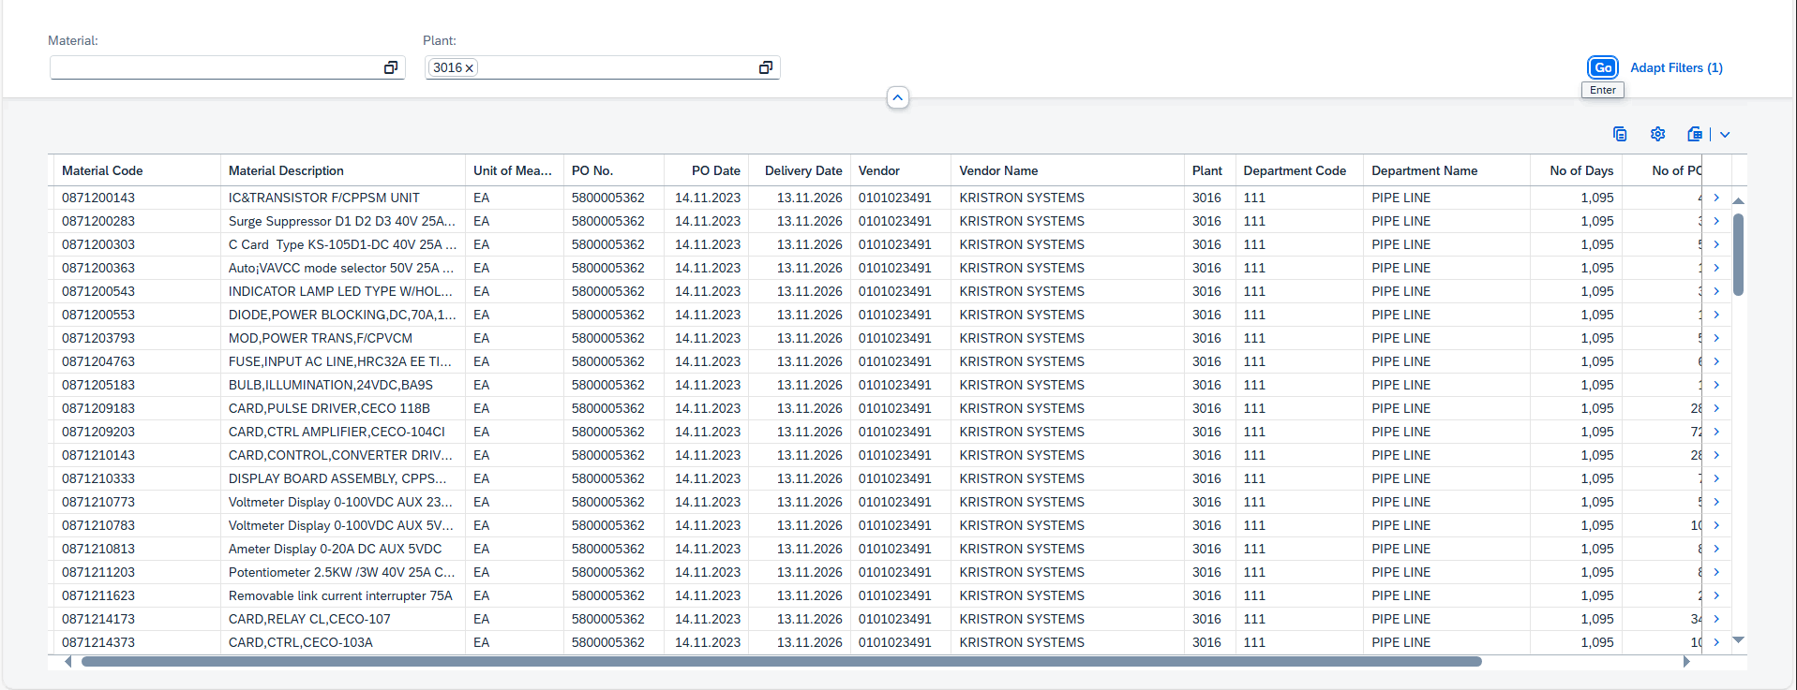

Logic:

- CDS: YRMR317_LEAD_TIME_RPT
This CDS view fetches data from table ekpo referred to as “T0” with 1 inner join and 4 left outer joins and groups them by material number (matnr) and base unit of measure (meins) to avoid duplicate entries, and with a where condition that checks the difference between the dates (ekko.bedat and ekpo.lewed) and filters records if the difference is more than or equal to 180 days.
1.1 Data is fetched from ekko referred to as “T1” based on a inner join with conditions, matching purchasing document number (ebeln) with “T0”, ebeln from ekpo starts with 51 or 52 or 57 or 58, Asset class marked for deletion (loekz) along with "Delivery Completed" Indicator elikz both from “T0” are initial, memory from ekko is initial, lewed from ekpo is not equal to “00000000” and material number from ekpo is between number starting from “08” to “99”.

1.2 Data is fetched from makt referred to as “T2” based on a left outer join where there is matching material number with “T0”.

1.3 Data is fetched from t024 referred to as “T3” based on a left outer join where there is matching requirement tracking number from “T0” with purchasing group from “T3”.

1.4 Data is fetched from lfa1 referred to as “T4” based on a left outer join where there is matching account number of supplier with “T1”.

- CDS: YRMR317_COUNT_MATNR
This CDS view fetches data from table ekpo where purchasing document number starts with any one of the numbers (51, 52, 57, 58) and asset class marked for deletion is empty and then groups them by material number (matnr) to avoid duplicate entries.
2.1 The final CDS view comprises of the following fields:
- T0. ebeln as ebeln,
- T1. lifnr as lifnr,
- T0. ebelp as ebelp,
- T0. werks as werks,
- T0. bednr as bednr,
- T0. meins as meins,
- T0. netpr as netpr,
- T0. elikz as elikz,
- T0. lewed as lewed,
- T0. kzwi2 as kzwi2,
- T0. bsgru as bsgru,
- T1. bedat as bedat,
- T2. maktx as maktx,
- T1. ekgrp as ekgrp,
- T3. eknam as eknam,
- T4.name1 as name1,
- T5.cnt as cnt,
- dats_days_between((T1. bedat), (T0.lewed) ) as lead_days,
- T0. ebeln as l_ebeln,
- T1. bedat as l_bedat
3.Metadata : YRMR317_MD_LEAD_TIME_RPT
Once the data is fetched from the CDS, a metadata is created to define the UI of the fiori app.

3. Service Definition Exposure: YRMR317_SD_LEAD_TIME_RPT
Once the metadata is defined for the CDS view entity elements, it is exposed through a service definition. This step makes the data accessible for external systems to consume.
4. Service Binding and Maintenance: YRMR317_SB_LEAD_TIME_RPT
The service definition is bound and maintained. This ensures that the service is available to the desired applications and users.
5. Fiori Tile Creation and Role Assignment
A Fiori tile is created to display the data exposed by the service. Additionally, roles are assigned to ensure that only authorized users can access and view this tile.

Table Creation
N/A

Security /Authorization
N/A

User Exit
N/A

Transaction / Batch Job that will access enhancement
N/A

Anticipated performance Issues (if any)
N/A

Registration
N/A

Assumptions/ Notes

Unit Test Case
Screenshot for testing

- Report Screen:

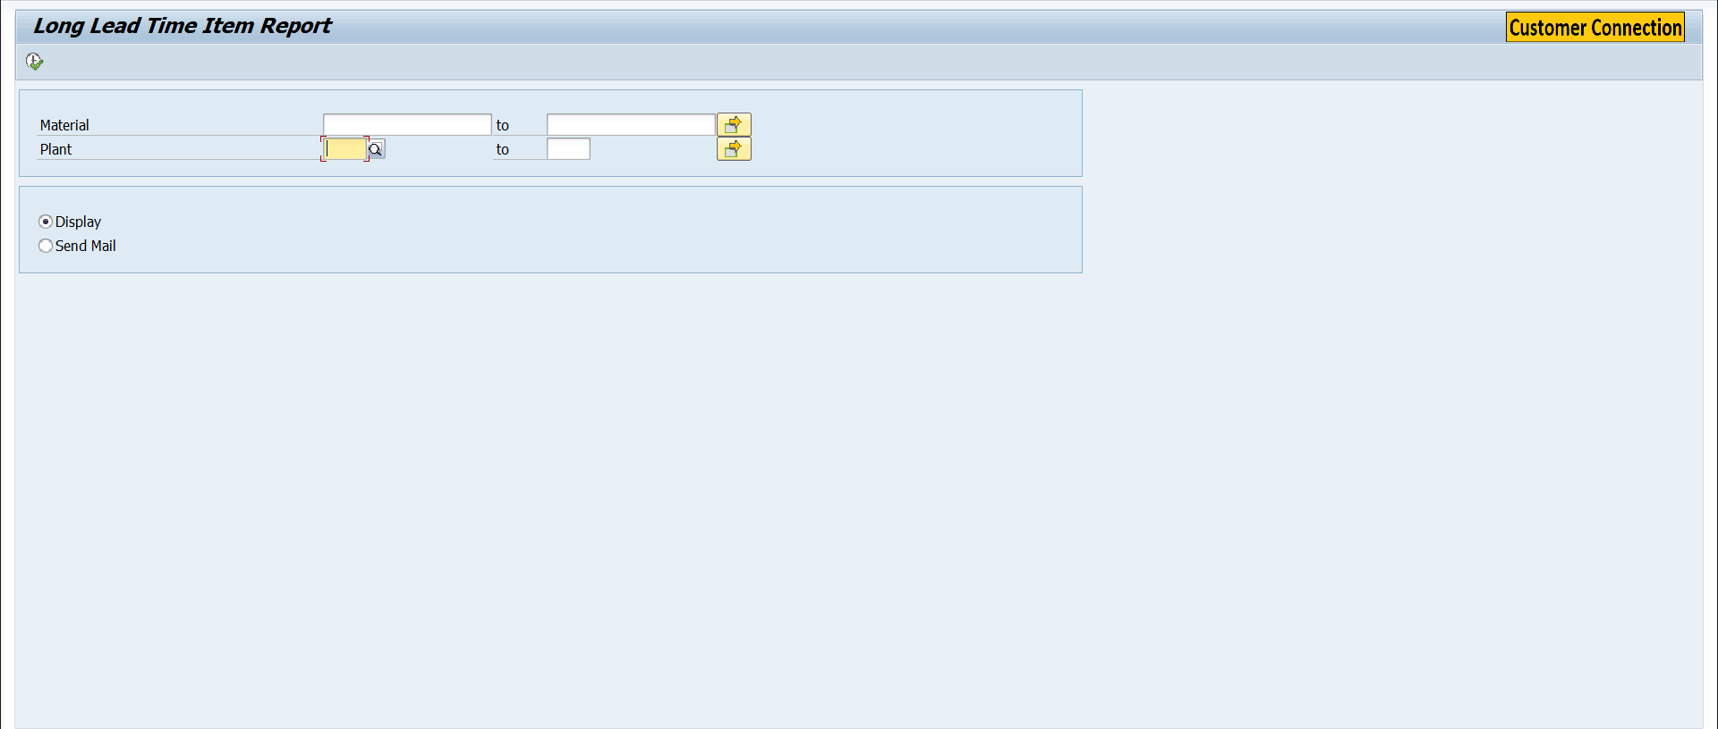
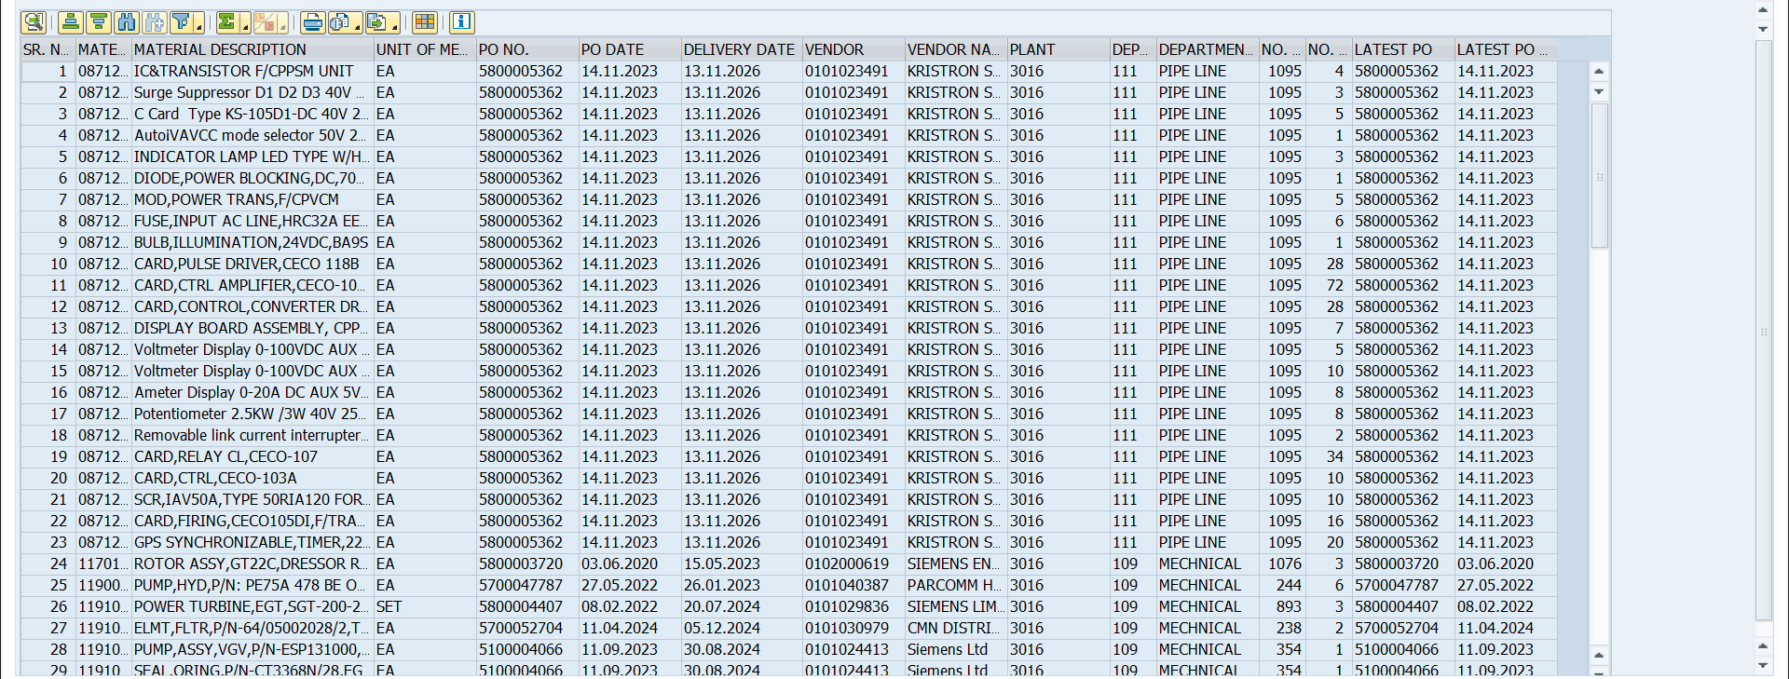

- Fiori Screen:


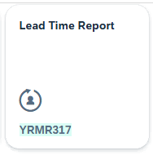

Technical Spec Original Sign Off:

Names and Signatures:

_____________ARNAV JOHRI_______________________________ Date: ___26/05/2025________

____________________________________________________ Date: _____________

____________________________________________________ Date: _____________

____________________________________________________ Date: _____________

Modifications
< Description of Modification if any>
<Support document of the modification like screen shot of email received>

